Geometric Relationships

Definition
# Source: AI Source: Provided by: [Data Path: Persons Table -> ID Column: 1, Name_En Column: Motasem Essam] -> From: [ChatGPT] on [7/25/2026]
Geometric Relationships are the mathematical connections between geometric figures and elements based on properties such as shape, size, position, proportion, angles, lengths, and symmetry.
They help us determine how geometric objects relate to one another and whether figures are congruent, similar, symmetric, parallel, perpendicular, or related by a transformation.
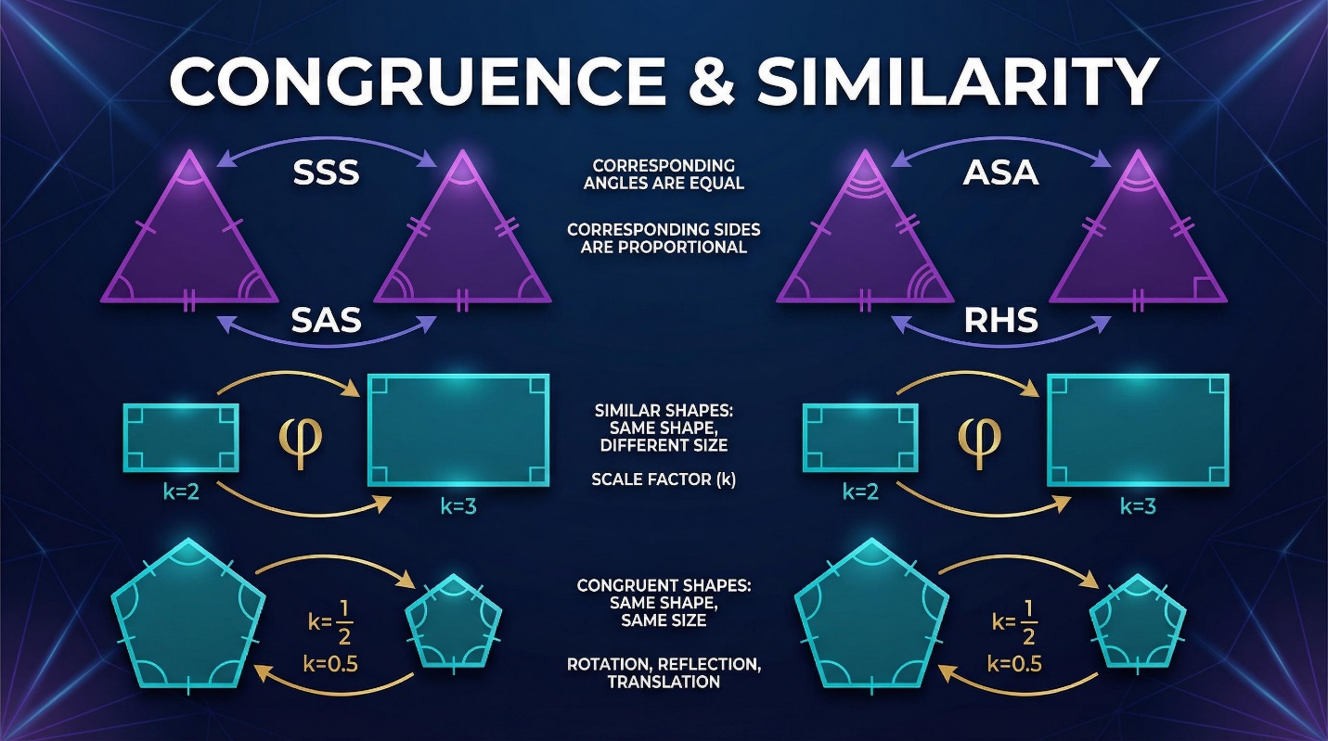
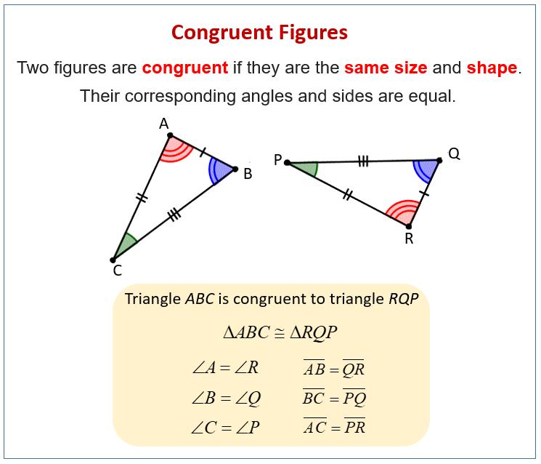
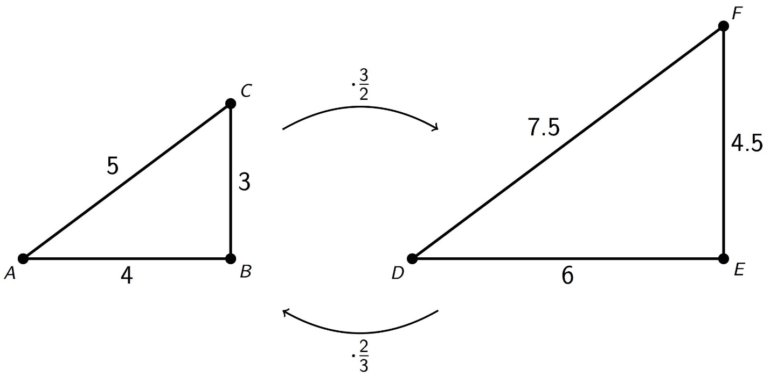
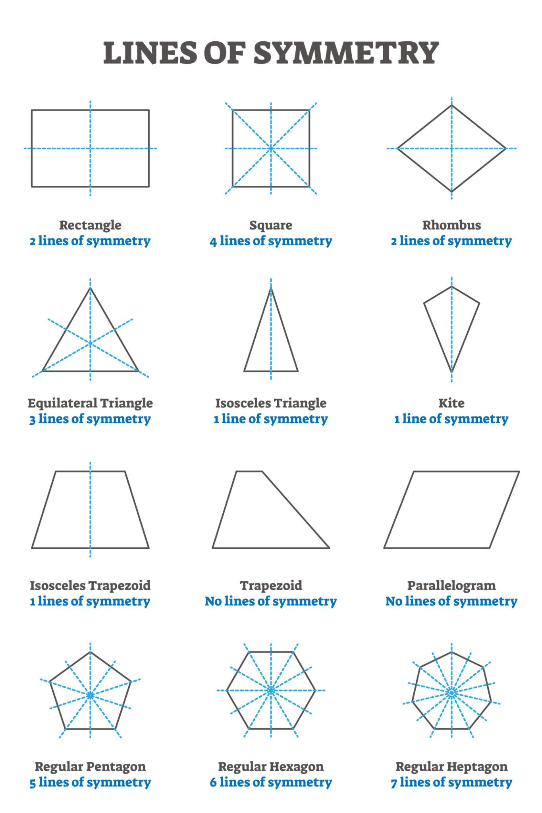
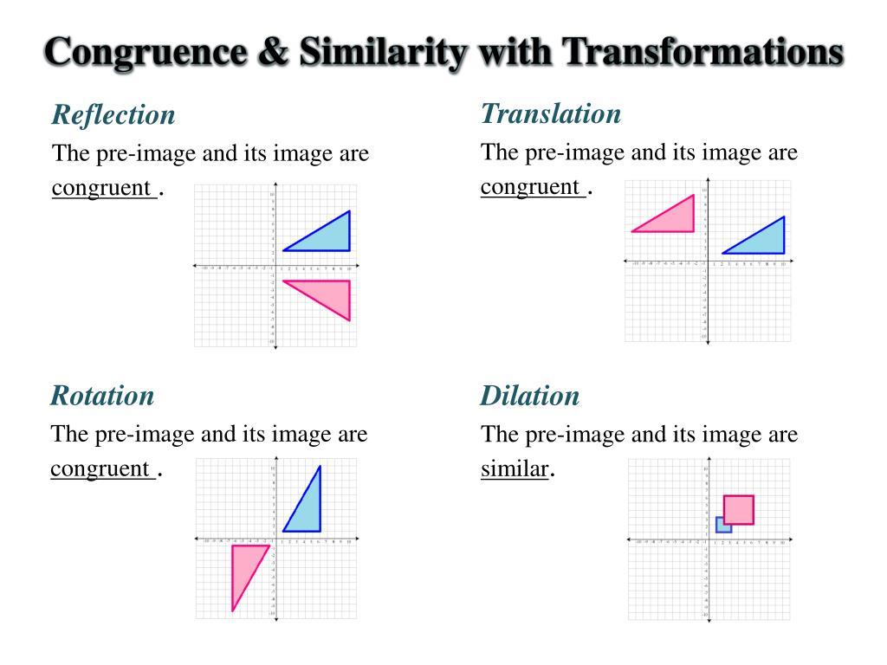
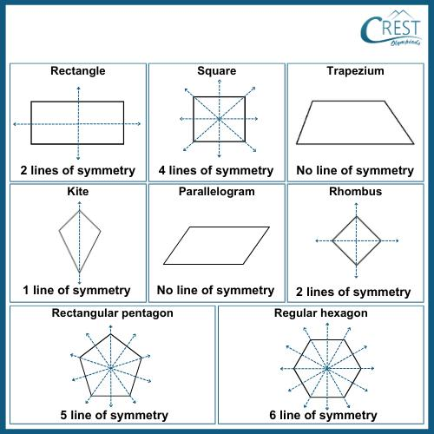

Purpose
# Source: AI Source: Provided by: [Data Path: Persons Table -> ID Column: 1, Name_En Column: Motasem Essam] -> From: [ChatGPT] on [7/25/2026]
Geometric relationships are used to:
- Compare geometric figures.
- Determine whether two figures have the same shape and size.
- Determine whether figures have the same shape but different sizes.
- Identify symmetrical figures.
- Analyze relationships between lines, angles, and shapes.
- Understand geometric transformations.
- Solve geometric problems.
- Establish geometric proofs.
- Support engineering, architecture, design, and computer graphics.

Main Types of Geometric Relationships
# Source: AI Source: Provided by: [Data Path: Persons Table -> ID Column: 1, Name_En Column: Motasem Essam] -> From: [ChatGPT] on [7/25/2026]
The major relationships in this section are:
- Congruence
- Similarity
- Symmetry

1. Congruence
# Source: AI Source: Provided by: [Data Path: Persons Table -> ID Column: 1, Name_En Column: Motasem Essam] -> From: [ChatGPT] on [7/25/2026]
Definition
Congruence is a relationship between two geometric figures that have exactly the same shape and the same size.
Congruent figures may be positioned or oriented differently, but their corresponding sides and angles are equal.
Notation:
$$\boxed{≅}$$
Example:
$$△ABC≅△DEF$$
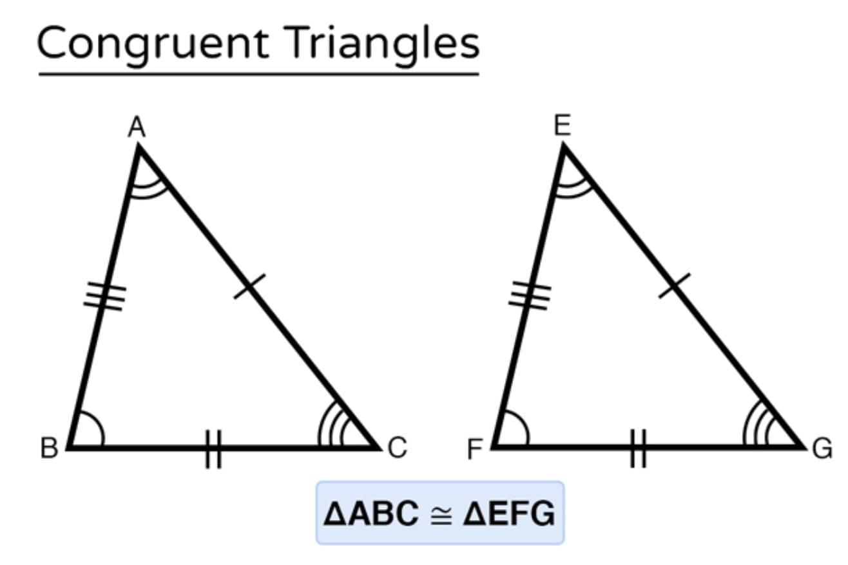
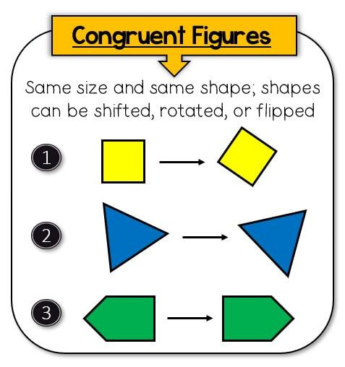
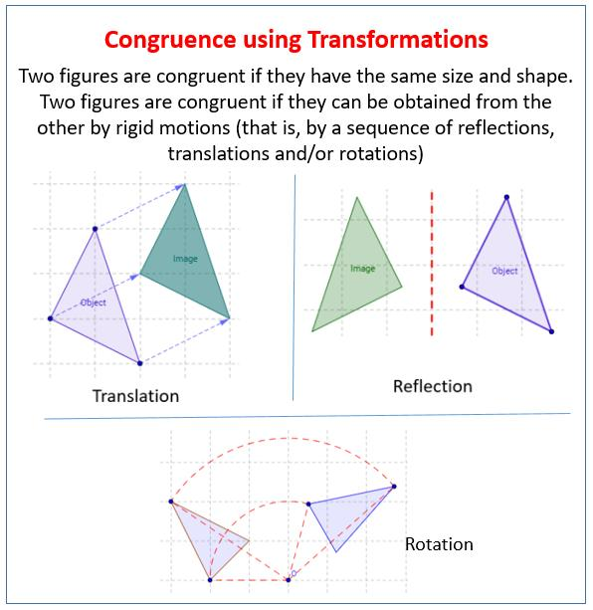
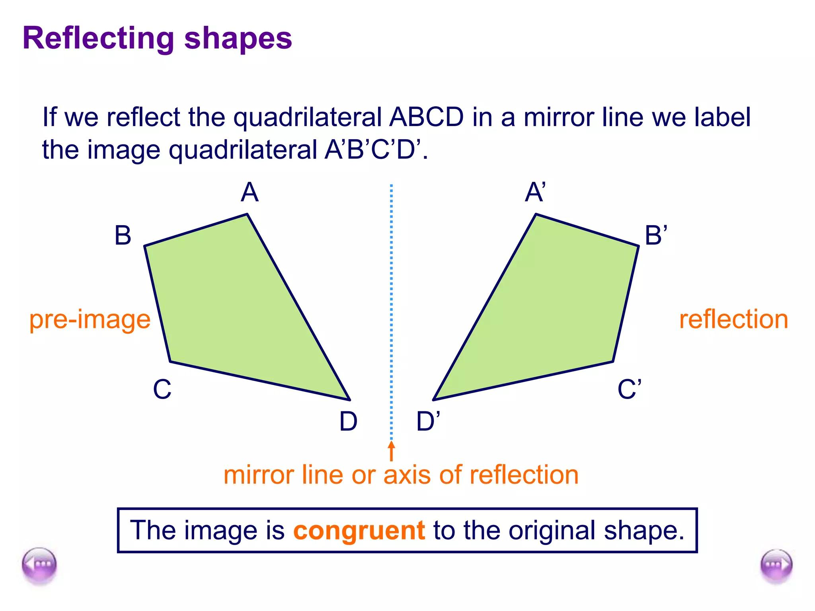
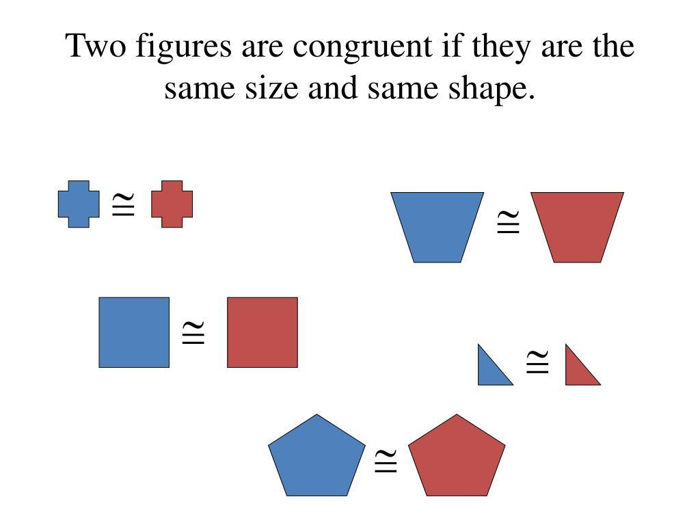
Properties
Congruent figures have:
- Equal corresponding side lengths.
- Equal corresponding angle measures.
- The same shape.
- The same size.
- The same corresponding dimensions.
Congruence can result from rigid transformations, including:
- Translation
- Rotation
- Reflection

2. Similarity
# Source: AI Source: Provided by: [Data Path: Persons Table -> ID Column: 1, Name_En Column: Motasem Essam] -> From: [ChatGPT] on [7/25/2026]
Definition
Similarity is a relationship between two geometric figures that have the same shape but not necessarily the same size.
Corresponding angles are equal, while corresponding side lengths are proportional.
Notation:
$$\boxed{∼}$$
Example:
$$△ABC∼△DEF$$
If the scale factor is $k$:
$$\frac{AB}{DE}=\frac{BC}{EF}=\frac{CA}{FD}=k$$
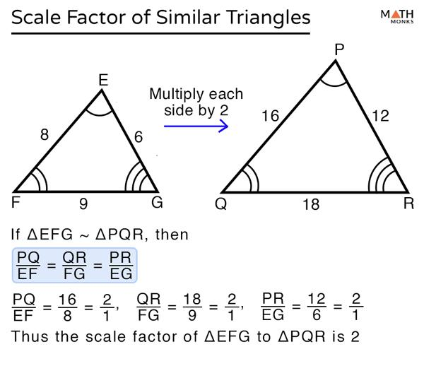
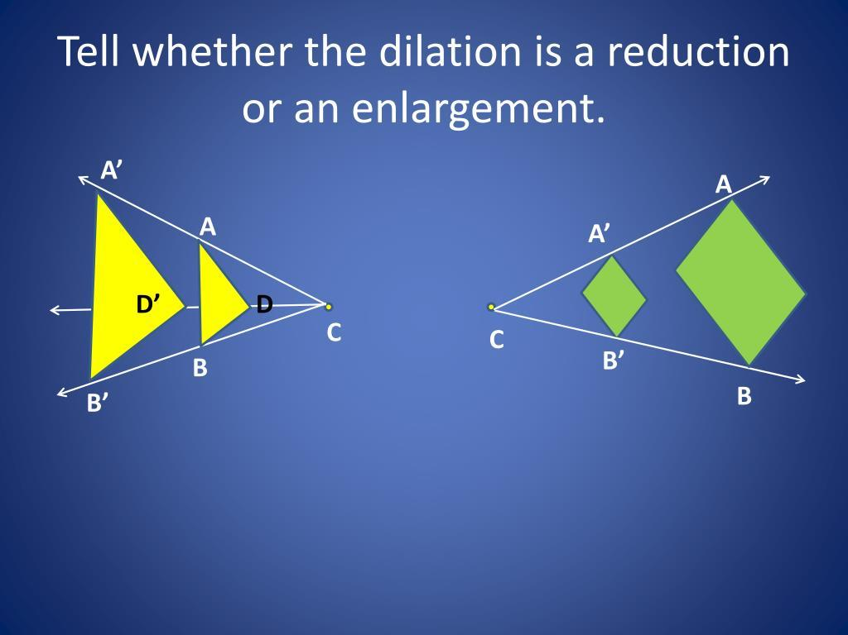
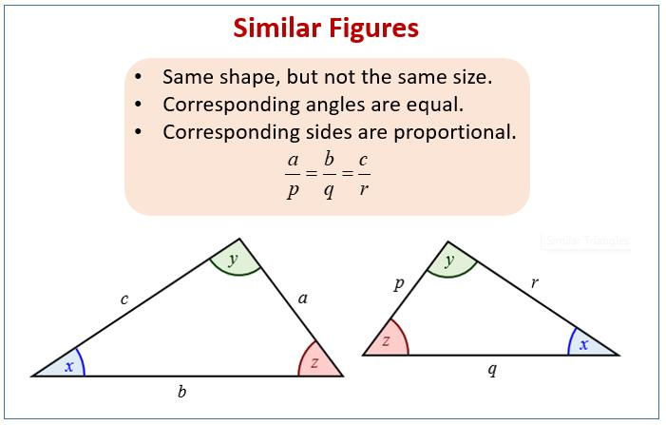
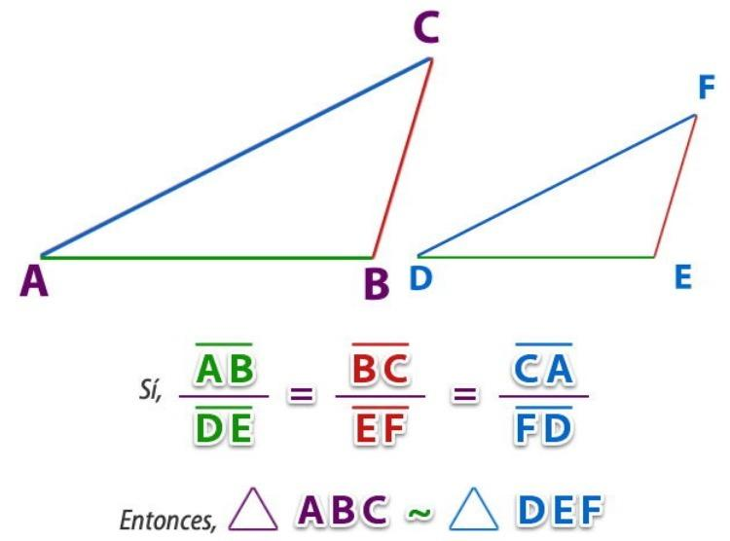
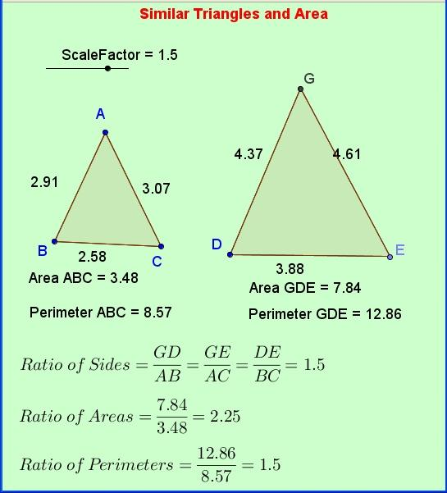
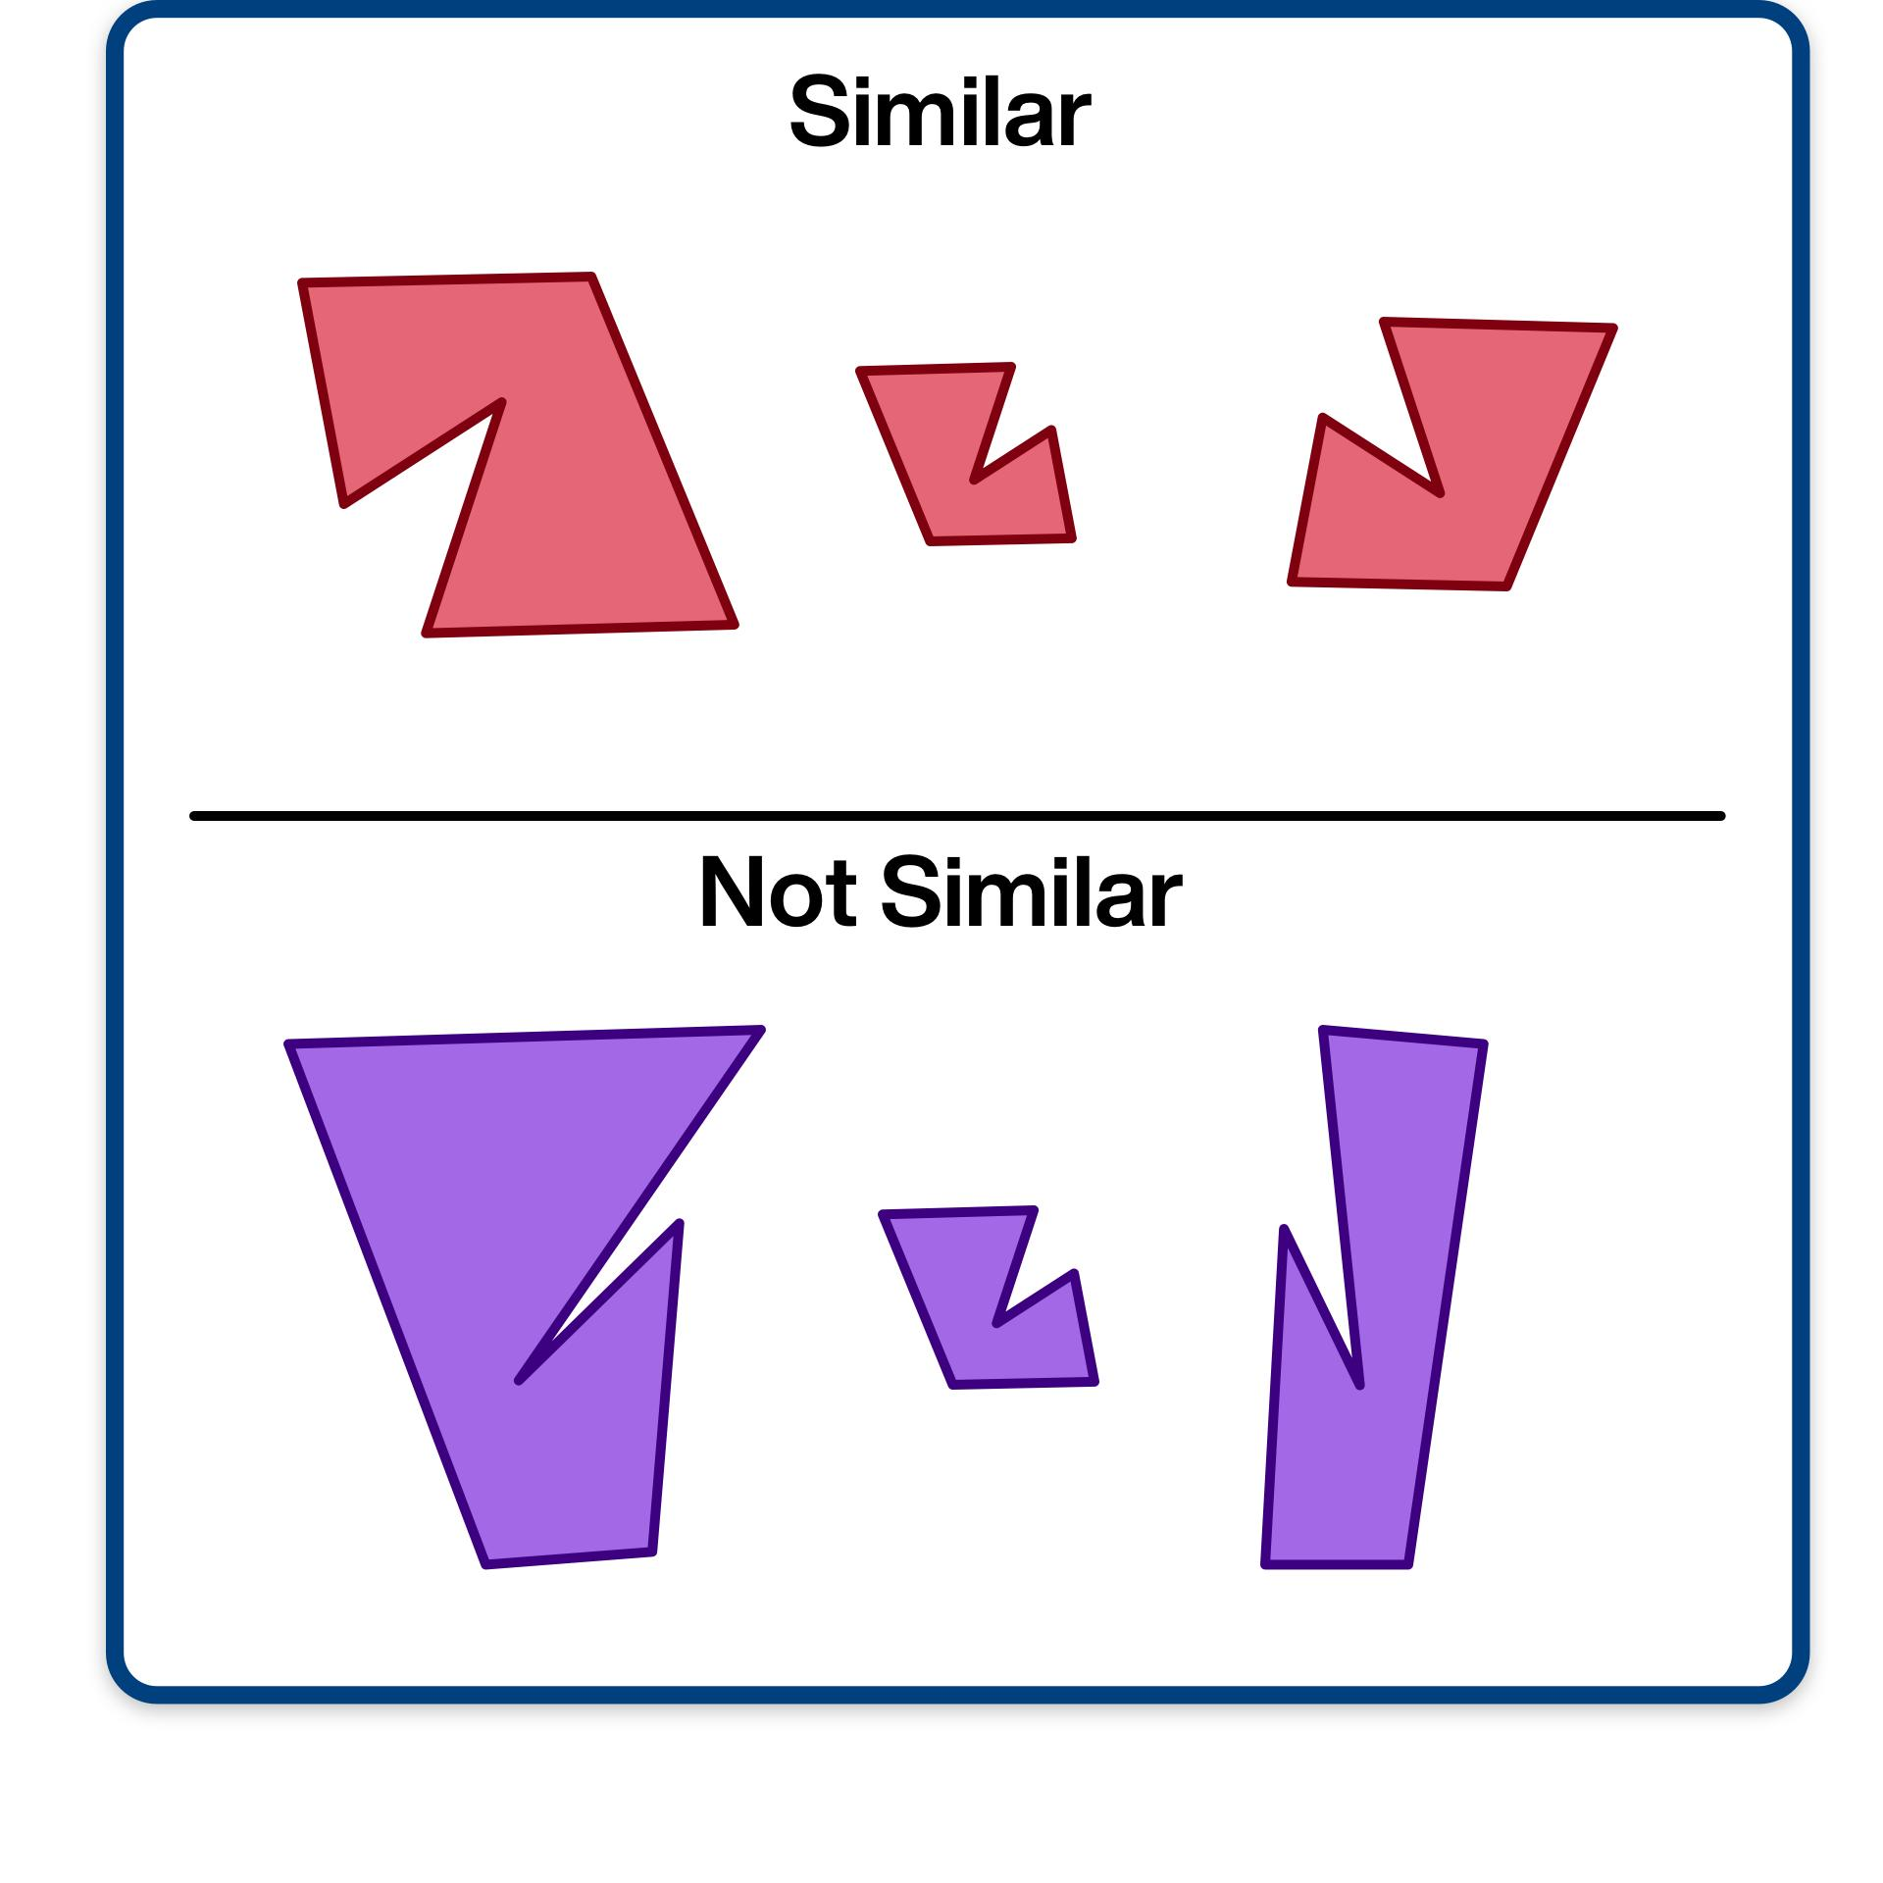
Properties
Similar figures have:
- The same shape.
- Equal corresponding angles.
- Proportional corresponding sides.
- Possibly different sizes.
Similarity is commonly associated with dilation.

3. Symmetry
# Source: AI Source: Provided by: [Data Path: Persons Table -> ID Column: 1, Name_En Column: Motasem Essam] -> From: [ChatGPT] on [7/25/2026]
Definition
Symmetry is a geometric relationship in which a figure has a balanced arrangement, where parts of the figure correspond to one another according to a particular transformation.
The two major types in this section are:
- Line Symmetry
- Rotational Symmetry
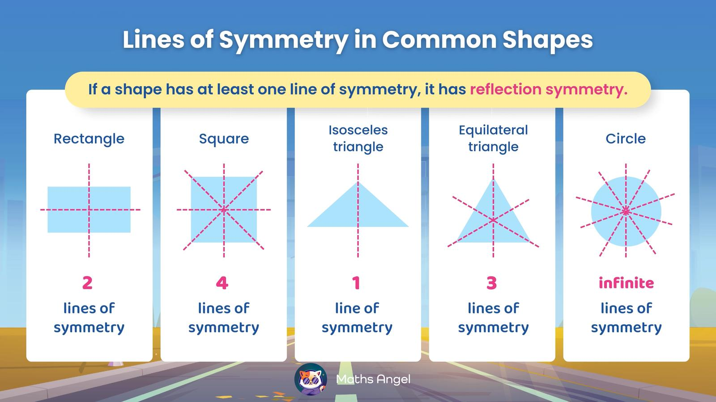
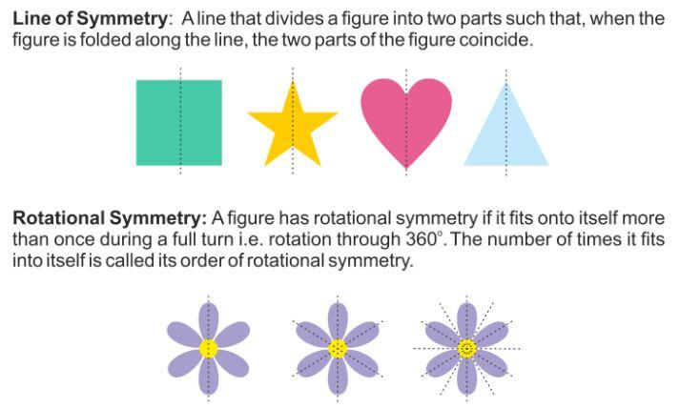
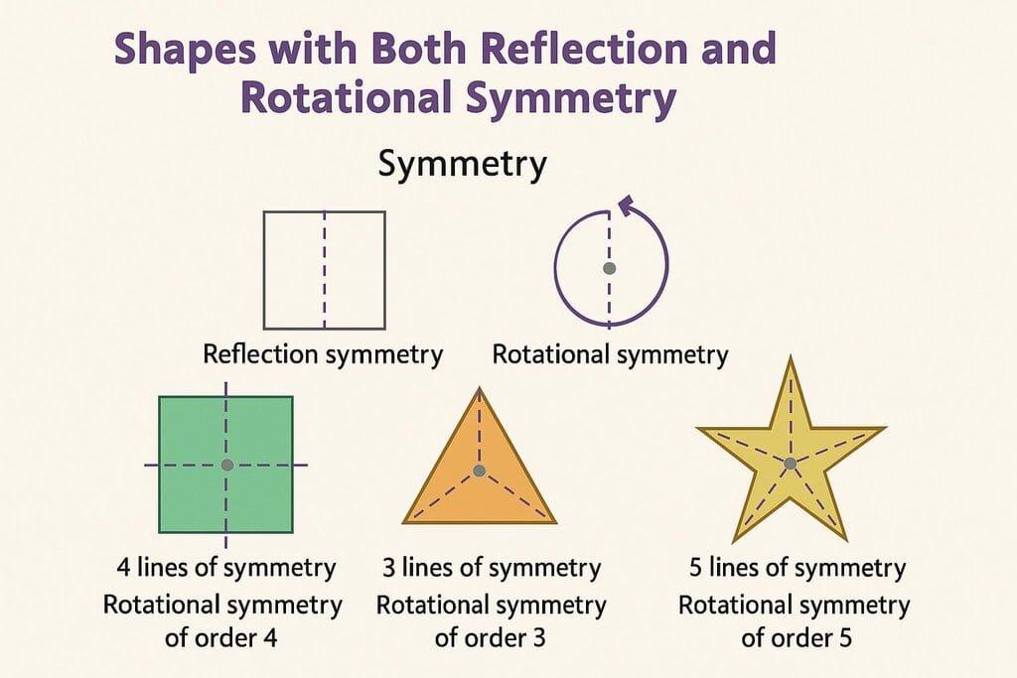
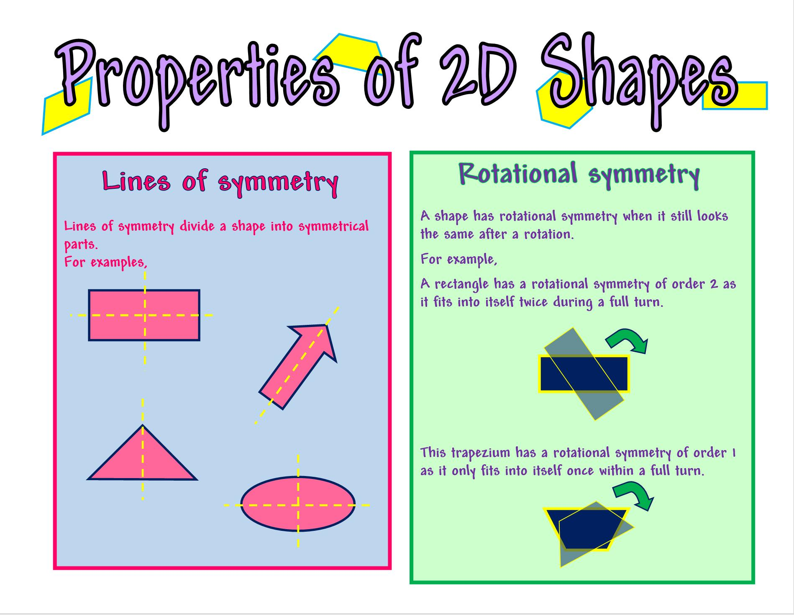
A figure can have:
- One line of symmetry.
- Several lines of symmetry.
- No line of symmetry.
- Rotational symmetry.
- Both line and rotational symmetry.

Geometric Relationships in Common Shapes
# Source: AI Source: Provided by: [Data Path: Persons Table -> ID Column: 1, Name_En Column: Motasem Essam] -> From: [ChatGPT] on [7/25/2026]
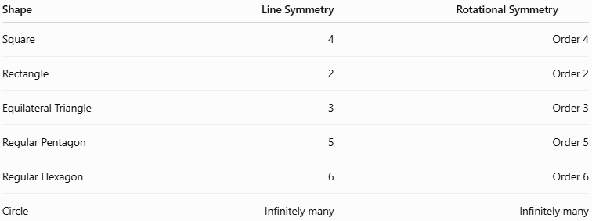
Shape | Line Symmetry | Rotational Symmetry
Square | 4 | Order 4
Rectangle | 2 | Order 2
Equilateral Triangle | 3 | Order 3
Regular Pentagon | 5 | Order 5
Regular Hexagon | 6 | Order 6
Circle | Infinitely many | Infinitely many
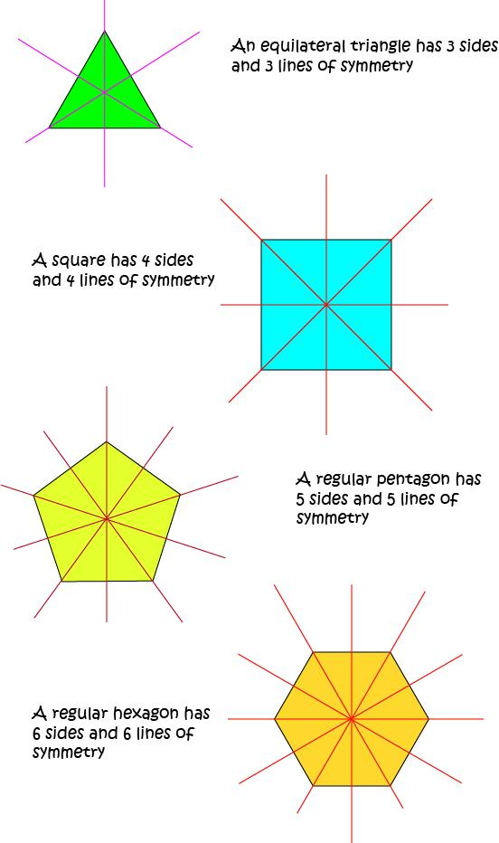
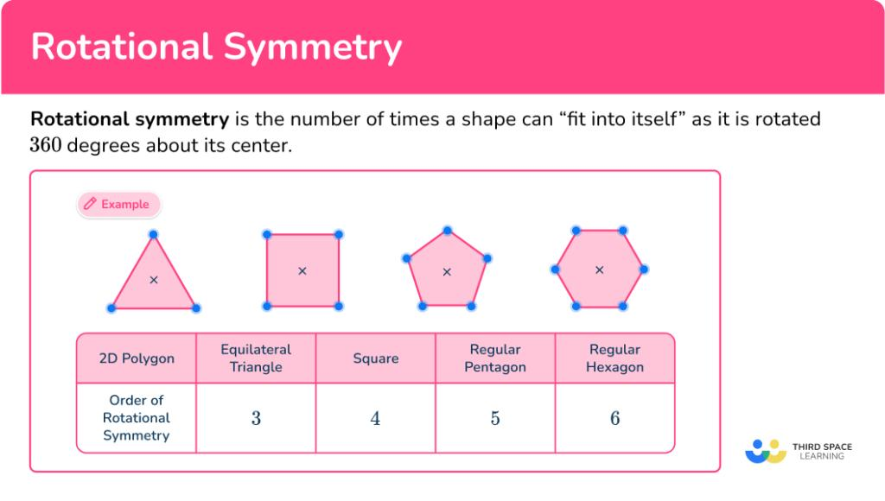
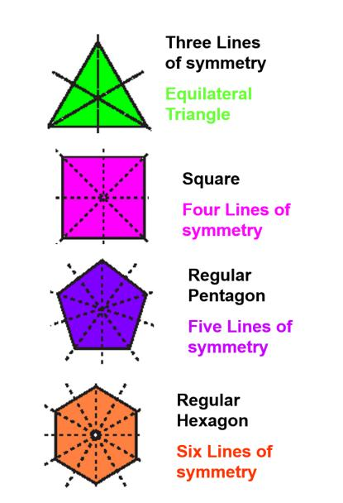
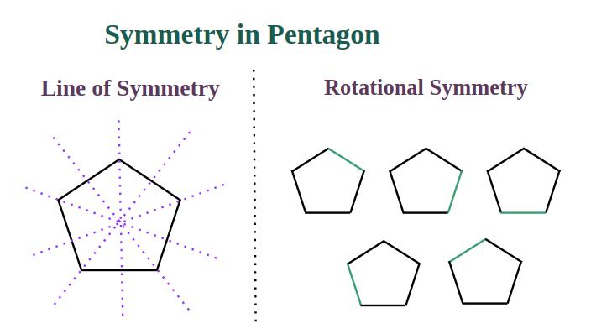
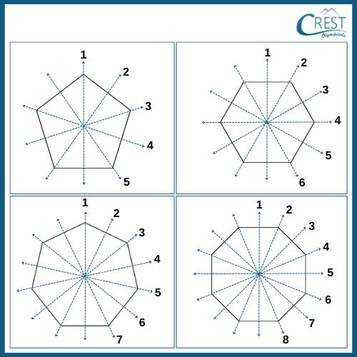

Congruence vs Similarity
# Source: AI Source: Provided by: [Data Path: Persons Table -> ID Column: 1, Name_En Column: Motasem Essam] -> From: [ChatGPT] on [7/25/2026]
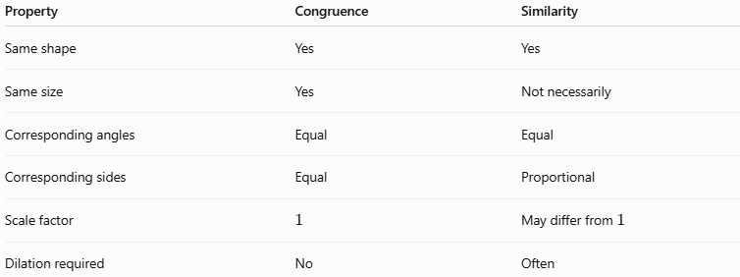
Property | Congruence | Similarity
Same shape | Yes | Yes
Same size | Yes | Not necessarily
Corresponding angles | Equal | Equal
Corresponding sides | Equal | Proportional
Scale factor | (1) | May differ from (1)
Dilation required | No | Often
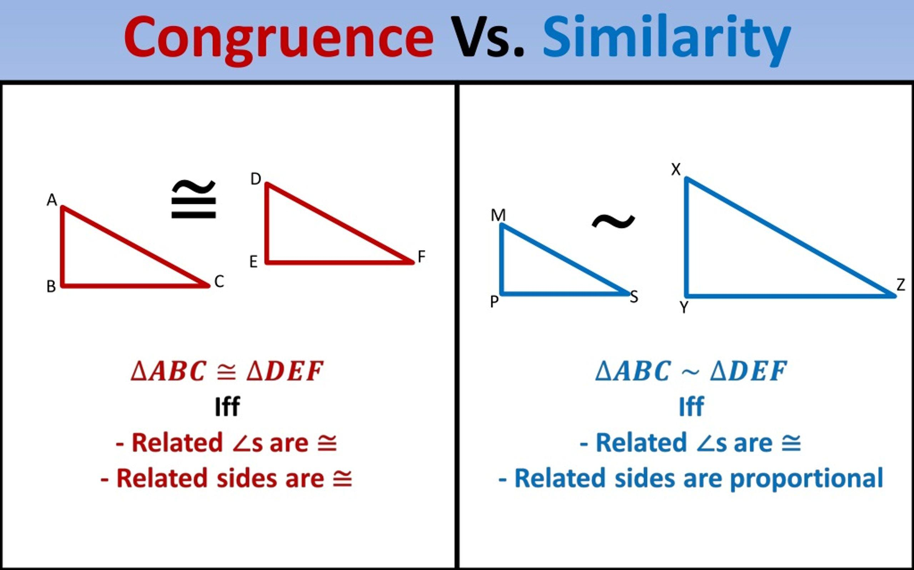
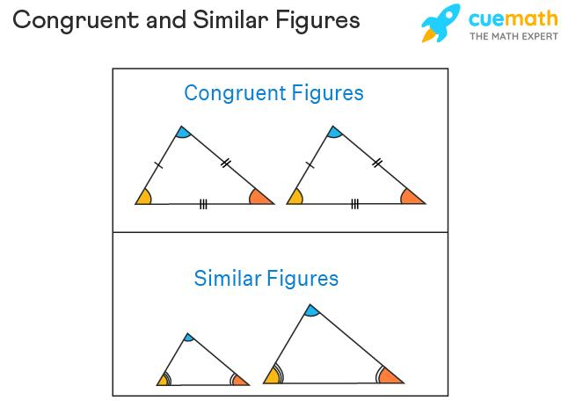
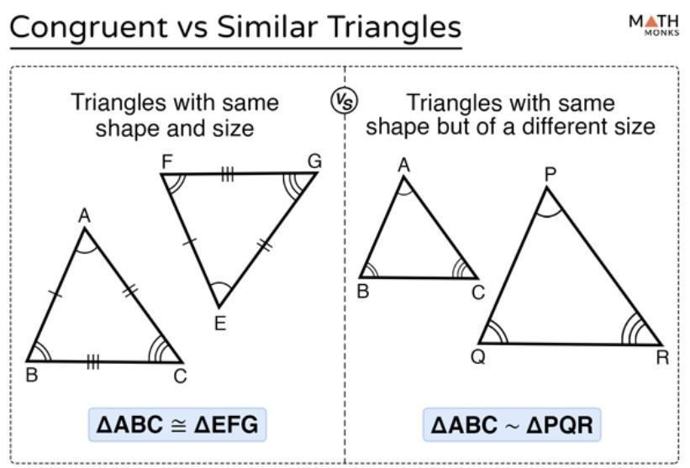
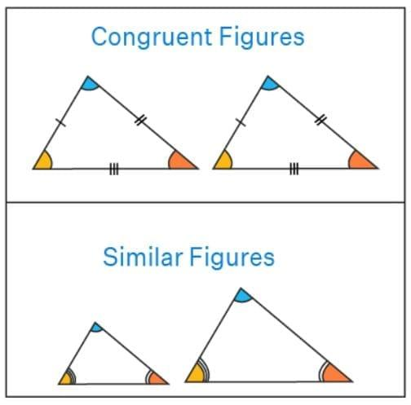

Relationship with Transformations
# Source: AI Source: Provided by: [Data Path: Persons Table -> ID Column: 1, Name_En Column: Motasem Essam] -> From: [ChatGPT] on [7/25/2026]
Geometric relationships are closely connected to transformations.
Translation
Moves a figure from one position to another without changing its shape or size.
Rotation
Turns a figure around a fixed point.
Reflection
Creates a mirror image of a figure.
Dilation
Changes the size of a figure while preserving its shape.
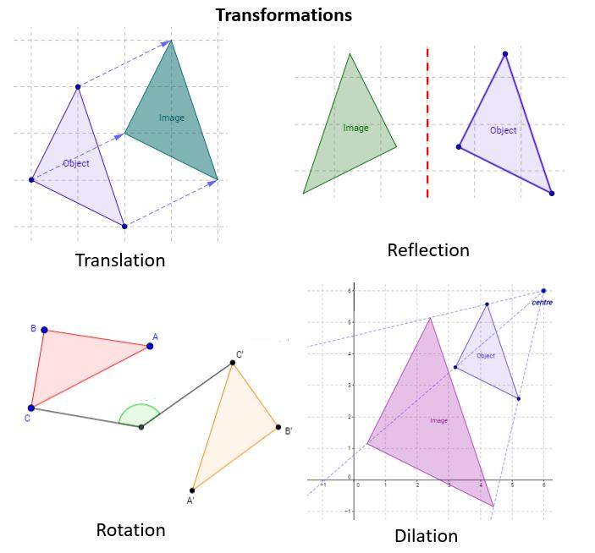
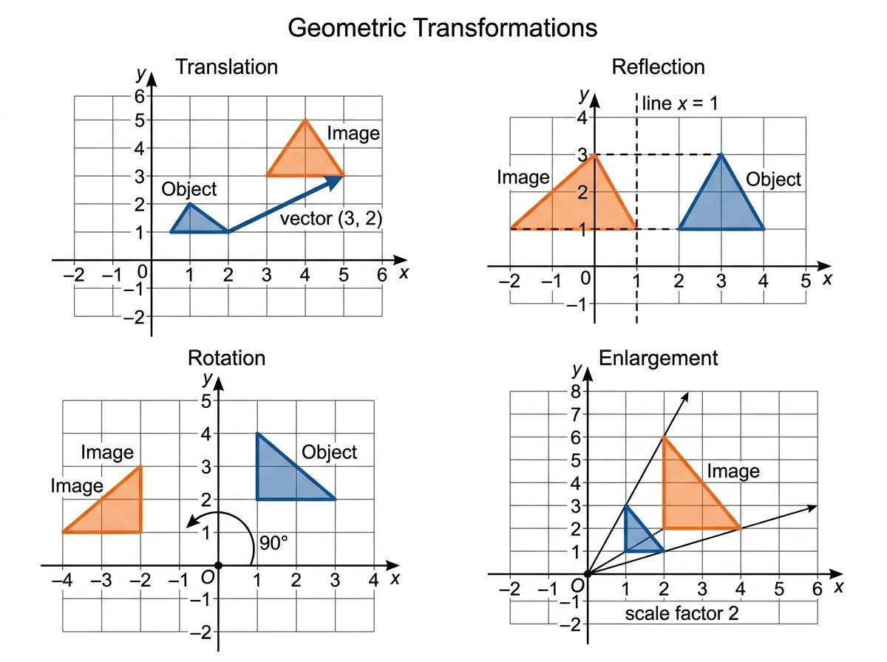
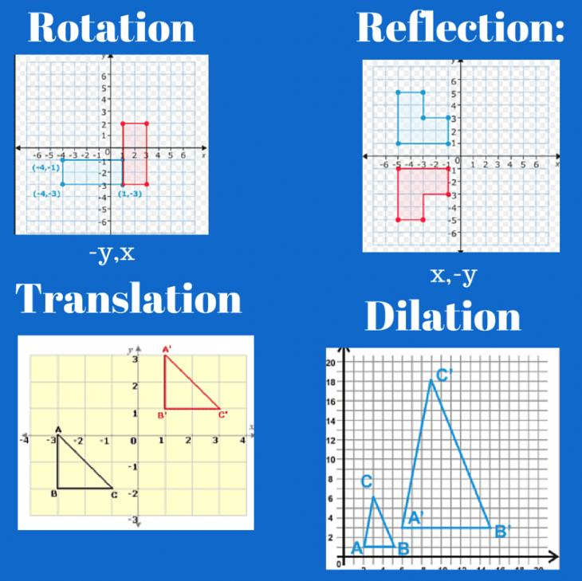
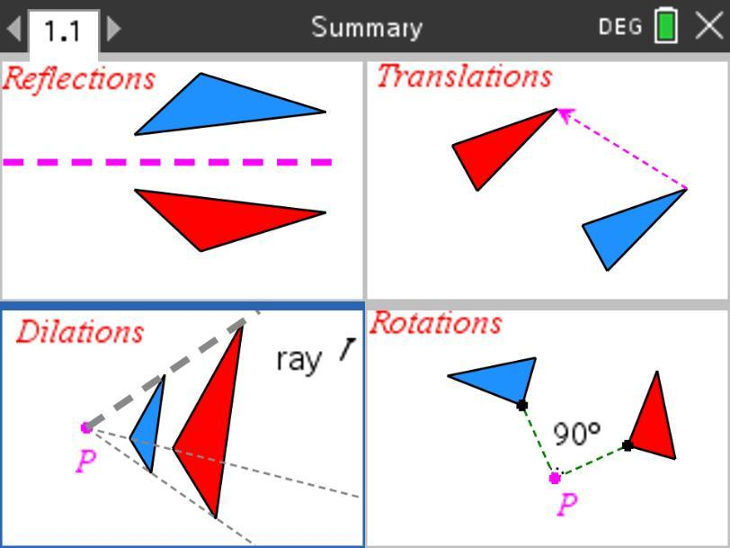

Mathematical Notation
# Source: AI Source: Provided by: [Data Path: Persons Table -> ID Column: 1, Name_En Column: Motasem Essam] -> From: [ChatGPT] on [7/25/2026]
Congruence
$$A≅B$$
means that $A$ and $B$ are congruent.
Similarity
$$A∼B$$
means that $A$ and $B$ are similar.
Equal Lengths
$$AB=CD$$
Equal Angles
$$∠A=∠B$$
Parallel Lines
$$AB∥CD$$
Perpendicular Lines
$$AB⊥CD$$
These are all examples of mathematical relationships between geometric objects.

Real-World Examples
# Source: AI Source: Provided by: [Data Path: Persons Table -> ID Column: 1, Name_En Column: Motasem Essam] -> From: [ChatGPT] on [7/25/2026]
Geometric relationships appear in:

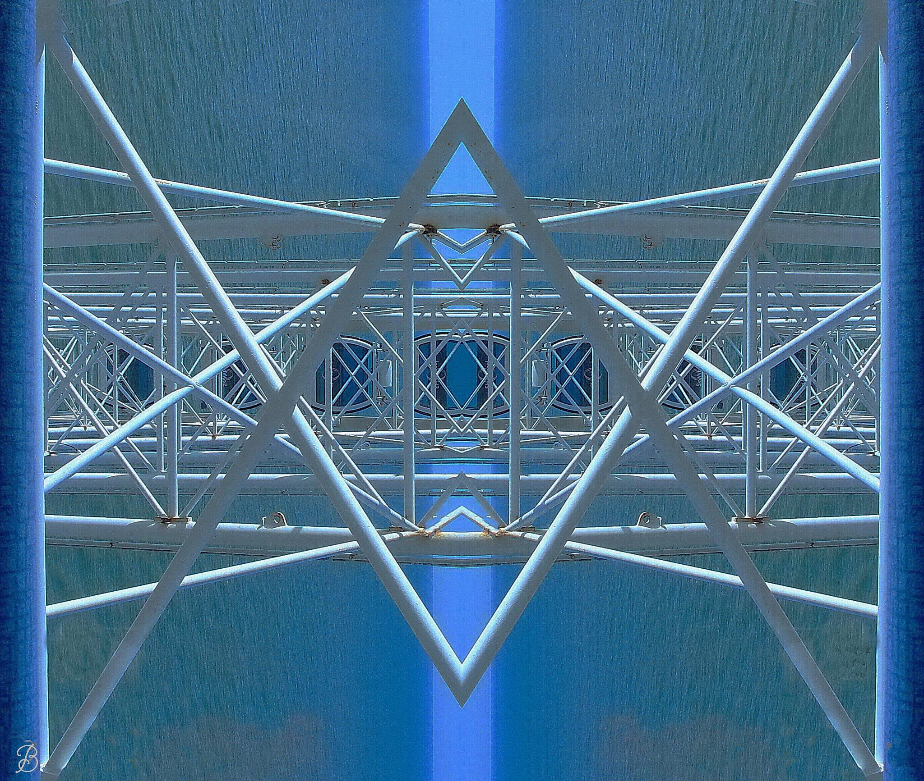
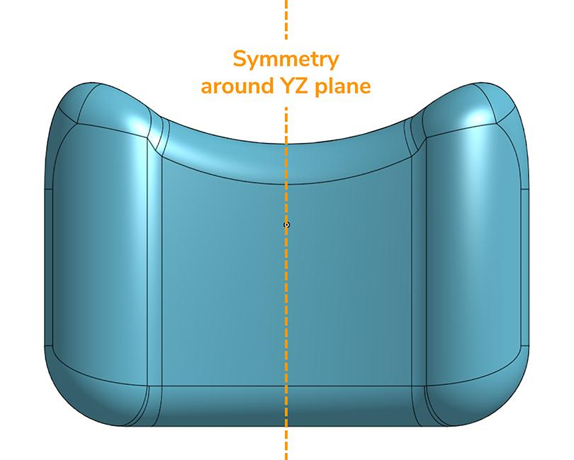

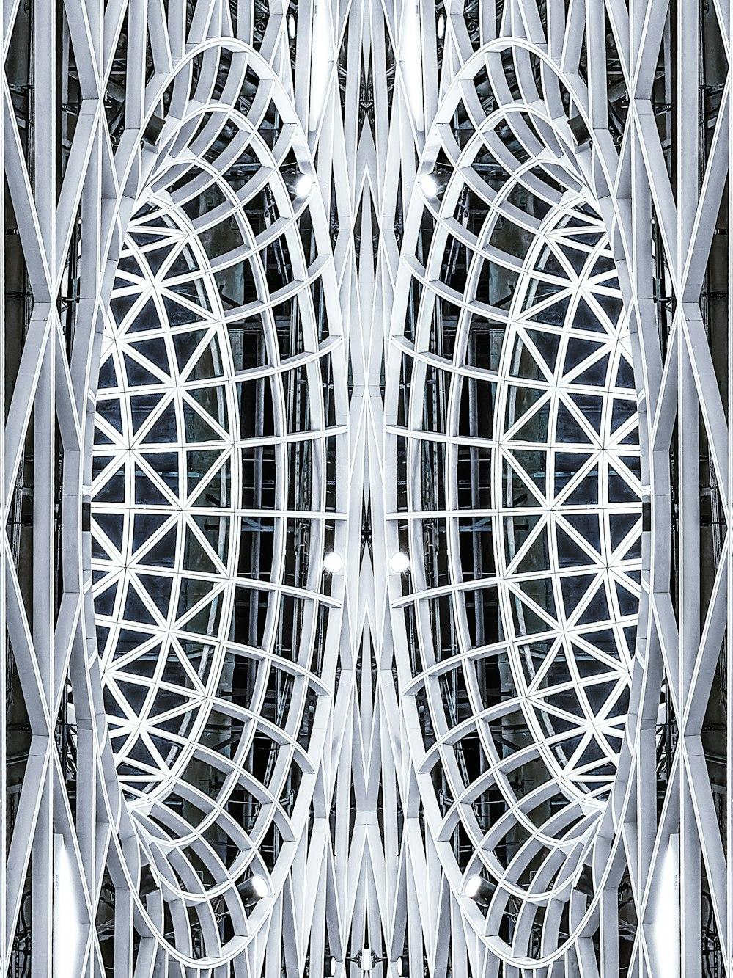
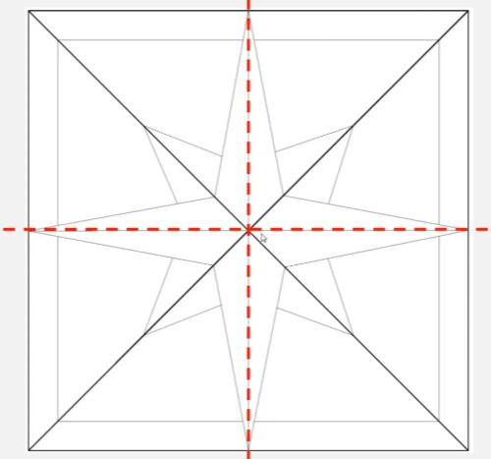

- Architecture
- Engineering
- Mechanical design
- Construction
- Product design
- Art
- Pattern design
- Computer graphics
- CAD
- Robotics
- Manufacturing
- Cartography
Examples include:
- Symmetrical buildings.
- Repeated patterns.
- Machine components.
- Scaled architectural drawings.
- Mirror designs.
- Rotating mechanical components.

Applications
# Source: AI Source: Provided by: [Data Path: Persons Table -> ID Column: 1, Name_En Column: Motasem Essam] -> From: [ChatGPT] on [7/25/2026]
Geometric relationships are important in:
- Plane Geometry
- Coordinate Geometry
- Trigonometry
- Engineering
- Architecture
- CAD
- Computer Graphics
- Robotics
- Manufacturing
- Surveying
- Cartography
- Industrial Design

Advantages
# Source: AI Source: Provided by: [Data Path: Persons Table -> ID Column: 1, Name_En Column: Motasem Essam] -> From: [ChatGPT] on [7/25/2026]
Studying geometric relationships helps to:
- Compare geometric figures.
- Identify equal and proportional figures.
- Understand symmetry.
- Analyze geometric structures.
- Simplify geometric proofs.
- Solve construction problems.
- Understand transformations.
- Design balanced and symmetrical objects.
- Analyze patterns and repeated structures.

Limitations
# Source: AI Source: Provided by: [Data Path: Persons Table -> ID Column: 1, Name_En Column: Motasem Essam] -> From: [ChatGPT] on [7/25/2026]
Geometric relationships:
- Often rely on ideal geometric figures.
- May require precise measurements or mathematical conditions.
- Can become complex when many figures and relationships are involved.
- May require algebra or trigonometry for advanced problems.
- Do not always directly describe irregular real-world objects.

Key Points
# Source: AI Source: Provided by: [Data Path: Persons Table -> ID Column: 1, Name_En Column: Motasem Essam] -> From: [ChatGPT] on [7/25/2026]
- Geometric Relationships describe mathematical connections between geometric objects.
- Congruence means the same shape and the same size.
- Similarity means the same shape with proportional dimensions.
- Symmetry describes balanced correspondence within a figure.
- Line Symmetry involves reflection across a line.
- Rotational Symmetry involves rotation around a fixed point.
- Transformations such as translation, rotation, reflection, and dilation are closely related to geometric relationships.
- Geometric relationships are fundamental to the study of geometric figures and their properties.

Conclusion
# Source: AI Source: Provided by: [Data Path: Persons Table -> ID Column: 1, Name_En Column: Motasem Essam] -> From: [ChatGPT] on [7/25/2026]
Geometric Relationships are the mathematical connections between geometric figures and elements based on properties such as shape, size, length, angle, position, proportion, and symmetry. Important relationships include congruence, similarity, line symmetry, and rotational symmetry. These concepts provide a systematic way to compare, classify, transform, and analyze geometric figures and are fundamental to plane geometry, engineering, architecture, CAD, computer graphics, design, and many other mathematical and technical fields.

